**Create a request, and collections and variables using Postman**

Step-1:

First open postman

Step-2:

Then I click on “+” sign to create a collection

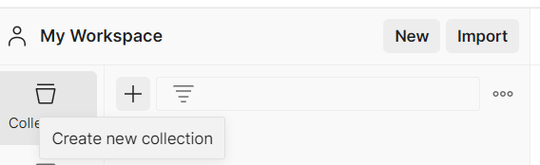

Step-3:

Then I click on Blank Collection

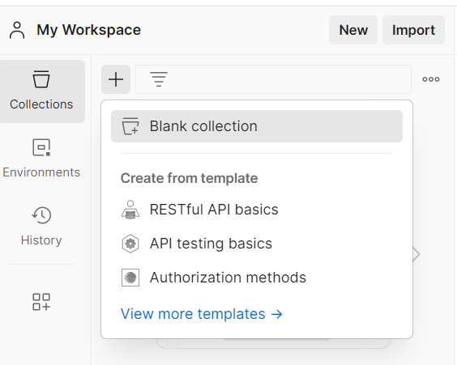

Step-4:

Then I click on 3 dot then select Add request

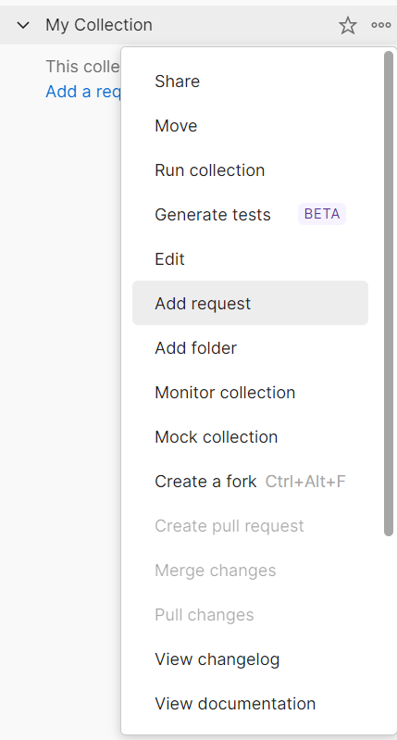

Step-5:

Then I rename it and enter request url

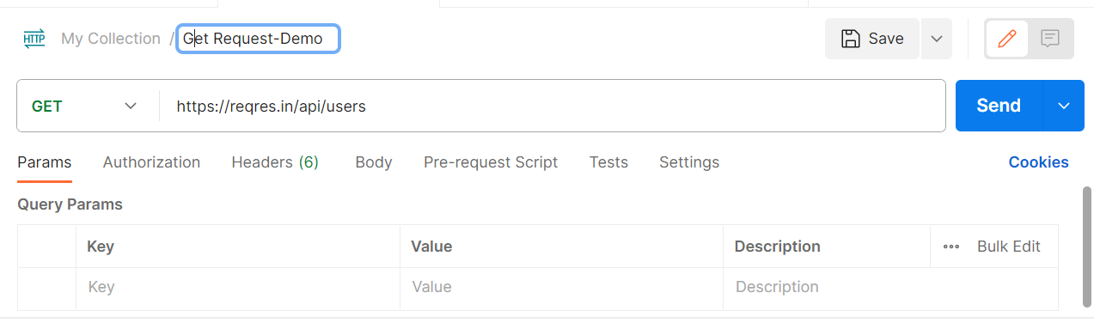

Step-6: Then I create a collection variable and save it

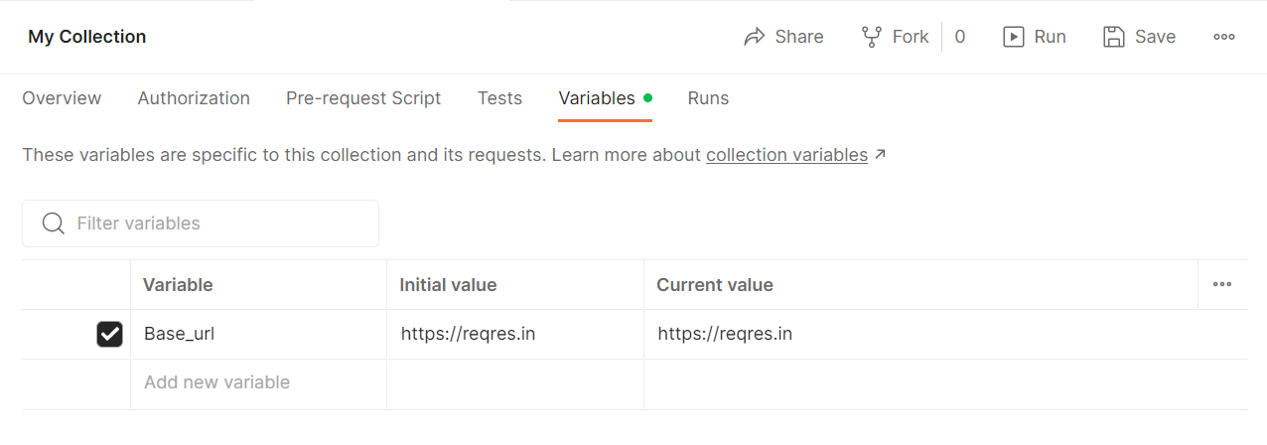

Step-7:

Then I give the collection variable in url and send

